**Mrs. Friedstat’s Newsletter**

**Math Interventionist**

**Month: October 2019**

**The following standards were covered during the month of October:**

**3rd Grade Standards**

**3.MD.8 Perimeter 3.OA.8 Solve two-step word problems involving addition, subtraction, multiplication and subtraction 3.MD.5 Area is measured in square units 3.MD.6 Area by counting**

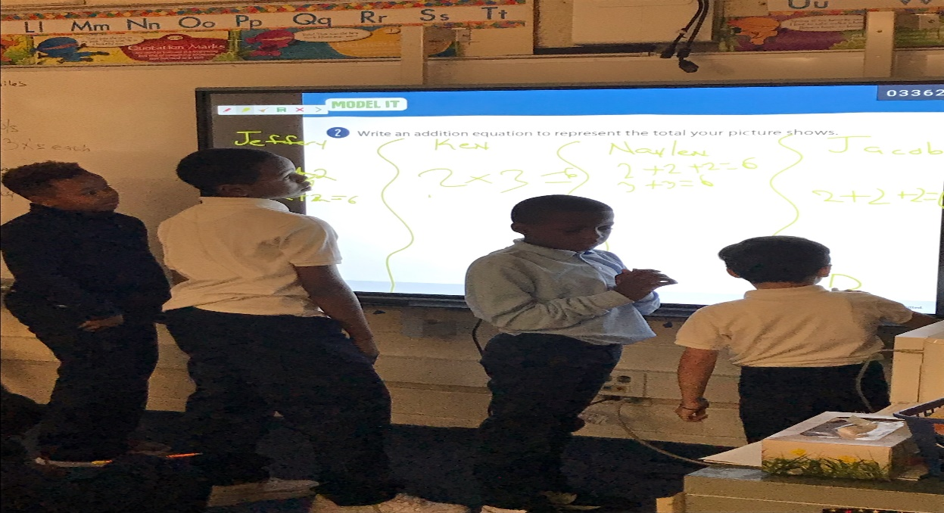

**Mr. William’s 3rd Grade Class Markham Park School**

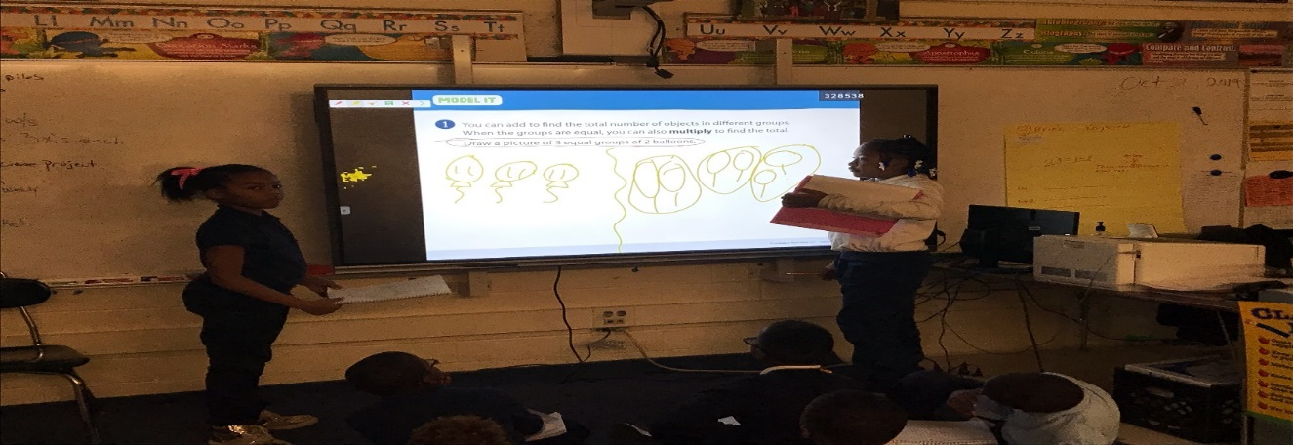

**4th Grade Standards**

**4.OA.4 Factor pairs/prime or composite**

**4.NBT.5 Multiply 4 digit by 1 digit, 2 digit by 2 digit**

**4.NBT.6 Divide 4 digit by 1 digit, 2 digit by 2 digit**

**4.OA.3 Multi Step Word Problems**

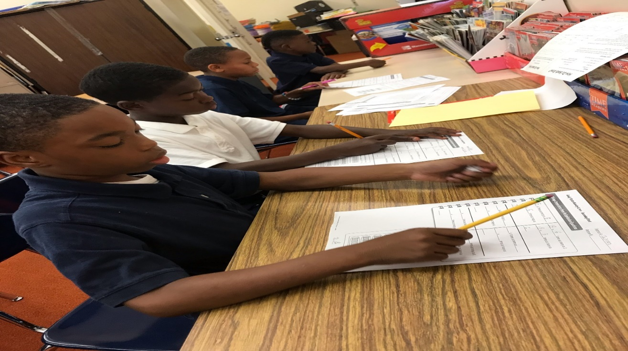

**Mrs. Gate’s 4th Grade Class**

**Chateaux School**

**5th Grade Standards**

**5.MD.3 Volume**

**5.MD.4 Volume using unit cubes**

**5.MD.5 Solve problems with volume using multiplication and addition**

**5.NBT.2 Multiplying by Powers of 10**

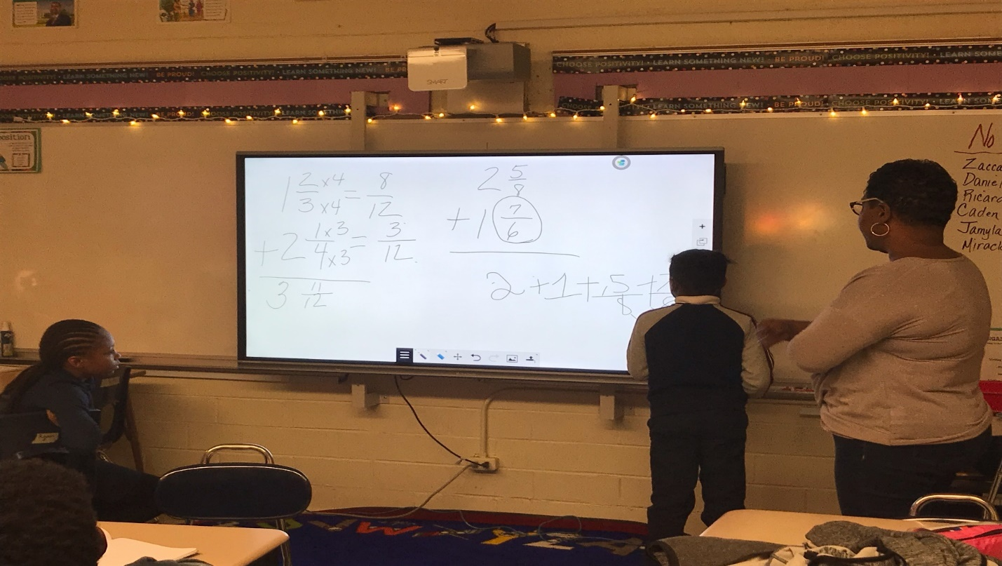

**Ms. Beamon’s 5th Grade Class**

**Markham Park**

**Monthly Math Tip**

**To Master Basic Math Facts: Strategize, Then Memorize By:** [**Carol R. Rinke**](https://www.parenttoolkit.com/expert/carol-r-rinke)

“Nothing may be more feared in the minds of young children and their parents than learning the basic math facts. Just hearing the times tables takes many of us back to our own childhoods, staring at a blank page and trying to remember the dreaded 9 x 8 = 72. The good news is that our own children should not have to suffer the same fear.”

Read this article to learn about some of the most common strategies for basic fact mastery.

<https://www.parenttoolkit.com/academics/news/math/to-master-basic-math-facts-strategize-then-memorize>